**NATIONAL YOUTH SERVICE CORPS,**

**EBONYI STATE SECRETARIAT**



**ANALYSIS OF SAMPLE OPINION SURVEY**

**(FORM 4A) OF CORPS MEMBERS CONDUCTED IN NYSC ORIENTATION CAMP, OLD MACGREGOR COLLEGE, AFIKPO,**

**EBONYI STATE**

**2024 BATCH ‘B’ STREAM 1 SERVICE YEAR, 2024.**

Table of Contents

INTRODUCTION 4

1.0 DEMOGRAPHY SECTION 4

1.1 STATE OF ORIGIN 4

1.2 GENDER OF THE RESPONDENTS 7

1.3 AGE OF THE RESPONDENTS 8

1.4 RELIGION OF THE RESPONDENTS 10

1.5 MARITAL STATUS OF THE RESPONDENTS 11

1.6 QUALIFICATION OF THE RESPONDENTS 12

2.0. MOBILIZATION FOR NATIONAL SERVICE SECTION 13

2.1 CONCESSIONAL DEPLOYMENT 13

2.2 CORPS MEMBERS’ FEELINGS ABOUT MOBILIZATION FOR NATIONAL SERVICE 14

2.3: RESPONDENT RATING ON THE PURPOSE FOR ESTABLISHING THE NYSC SCHEME 15

3.0. REGISTRATION SECTION 16

3.1 COLLECTION OF CALL-UP-LETTER METHODS 16

3.2 WHICH OF THESE TWO PROCESSES DO YOU THINK IS BETTER? 17

3.3 REGISTRATION IN CAMP 18

3.4 KIT COLLECTION 19

3.5 SATISFACTION ON KIT ISSUED. 20

3.6 RECEPTION GIVEN ON ARRIVAL TO CAMP 20

GIVEN RIGHT KIT SIZE 21

4.0 FEEDING SECTION 22

5.0. HEALTH CARE SECTION 23

5. 1 FUCTIONING OF THE CAMP CLINIC 24

6.0. CAMP ADMINISTRATION SECTION 25

6.1 CORPS MEMBERS CO-OPTED INTO CAMP COMMITEES 25

6.3 THE LEVEL OF CORPS MEMBERS’ PARTICIPATION IN CAMP ACTIVITIES 30

6.6 CAMP DISCIPLINE IN GENERAL 36

6.7 AMENABILITY OF CORPS MEMBERS TO NATIONAL SERVICE THROUGH ORIENTATION COURSE 38

6.8 MOST BORING ASPECT OF THE ORIENTATION COURSE 39

SUMMARY OF REPORT 43

RECOMMENDATION 45

# INTRODUCTION

This report presents the data analysis, findings, interpretations, and recommendations of data gathered from the corps members during the orientation activities within the specific timeframe. The total Population Sizes were 1,270 graduates of various universities, polytechnic and other Corps Producing Institutions (CPIs) registered within the period under review which serves as the total population from which the sample size for this analysis was extracted from.

According to the National Youth Service Corps (NYSC), the estimated recommendation for random sampling selections was 30% of the total population of graduates registered.

The sample sizes result revealed as follows (1,270 × 30%), gave 381 responses for this study. An Online survey was conducted with the use of Google form as a means of data collection. The structured questionnaires were self-administered to the corps members deployed to Ebonyi State, the data were was downloaded in Microsoft Excel format for proper data cleaning, normality check, analysis and interpretation of the results gathered from the findings. Data analysis and visualization were carried out using Python and Microsoft Excel whose results were presented in different sections and tables below. Comprehensive and detailed information on data findings will be provided for insight and implications of the study.

# DEMOGRAPHY SECTION

The distribution of the respondent (Corps Members) demography is presented in this section. The State of Origin, Age, Gender, Marital Status, Qualification and Religion are presented in this section.

### 1.1 STATE OF ORIGIN

Table 1 shows the frequency of the respondents and their percentage from each state while Table 2 Shows the frequency and percentage of respondents based on their geo-political zone.

Table 1 State of Origin of Respondents

|  |  |  |
| --- | --- | --- |
| State of Origin | Frequencies | Percentage |
| Abia | 2 | 0.5 |
| Akwa ibom | 15 | 3.9 |
| Anambra | 2 | 0.5 |
| Bayelsa | 10 | 2.6 |
| Benue | 6 | 1.6 |
| Cross River | 15 | 3.9 |
| Delta | 36 | 9.4 |
| Ebonyi | 5 | 1.3 |
| Edo | 54 | 14.2 |
| Ekiti | 12 | 3.2 |
| Enugu | 20 | 5.3 |
| Imo | 3 | 0.8 |
| Kaduna | 1 | 0.3 |
| Kogi | 10 | 2.6 |
| Kwara | 6 | 1.6 |
| Lagos | 15 | 3.9 |
| Nasarawa | 7 | 1.8 |
| Niger | 1 | 0.3 |
| Ogun | 43 | 11.3 |
| Ondo | 25 | 6.6 |
| Osun | 26 | 6.8 |
| Oyo | 45 | 11.8 |
| Plateau | 2 | 0.5 |
| Rivers | 19 | 5.0 |
| Zamfara | 1 | 0.3 |
| Total | 381 | 100.0 |

Table 2: Distribution of Respondents by Geo-Political Zones.

|  |  |  |
| --- | --- | --- |
| Geo-Political Zone | Frequency | Percentage (%) |
| North-East | 0 | 0 |
| North West | 6 | 0.6 |
| North-Central | 30 | 8.4 |
| South-East | 30 | 8.4 |
| South-West | 166 | 43.6 |
| South-South | 149 | 39 |
| Total | 381 | 100 |

Table 2 showed that most of the Corps members (43.6%) mobilized to Ebonyi state were from South West geopolitical zone. Corps members from South-South were 39%, South East Corps members were 8.4%, North West Corps members were 0.6%, North Central Corps members were 8.4% and North East Corps members were 0%.

From Table 1, it was also observed that the state of origin with the highest population of Corps members deployed to Ebonyi NYSC orientation camp is Edo state with a percentage of 14.17%. Chart 1.1 depicts a graphical representation of the number of Corps members deployed per state.

***Chart 1.1: Distribution of Corp Members Per State.***

### 1.2 GENDER OF THE RESPONDENTS

The gender distribution in frequency and percentage of the respondents (Corps Members) is shown in Table 3. Figure 1 shows the graphical representation of the distribution in percentage.

Table 3: Gender of the Respondents.

|  |  |  |
| --- | --- | --- |
| **Gender** | **Frequencies** | **Percentage(%)** |
| Male | 216 | 56.7 |
| Female | 165 | 43.3 |
| Total | 381 | 100.0 |

Table 1.2 above 56.7% of the corps members were Male while the remaining 43.3% happened to be female gender.

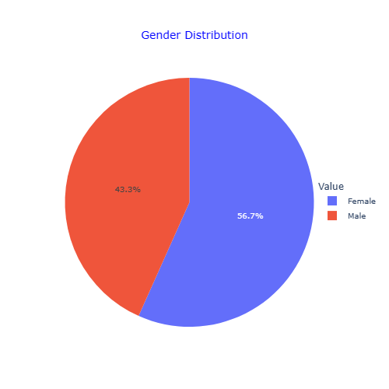

Figure 1: Gender Distribution of Respondents

### 1.3 AGE OF THE RESPONDENTS

The age distribution of the respondents is shown in Table 4. Table 5 shows the summary of statistics of the respondents’ age.

Table 4: Age of Respondents

|  |  |  |
| --- | --- | --- |
| Age | Frequency | Per cent |
| 23 | 65 | 17.1 |
| 24 | 63 | 16.5 |
| 25 | 51 | 13.4 |
| 26 | 43 | 11.3 |
| 27 | 42 | 11.0 |
| 22 | 31 | 8.1 |
| 28 | 28 | 7.3 |
| 29 | 27 | 7.1 |
| 21 | 14 | 3.7 |
| 30 | 8 | 2.1 |
| 20 | 6 | 1.6 |
| 19 | 2 | 0.5 |
| 32 | 1 | 0.3 |
| Total | 381 | 100.0 |

Table 5: Summary of Statistics of Respondent Age

|  |  |  |  |  |
| --- | --- | --- | --- | --- |
| Variable | Mean | Std. Dev | Minimum Age | Maximum Age |
| Age | 24.95 | 2.40 | 19 | 32 |

From Table 4 it is observed that the majority of the respondents (Corps Members) are of the age of 23 years with a percentage of 17.1% of the entire population. Also, respondents between the ages of 19 and 32 years have the lowest proportion with a percentage of 0.5% and 0.3% respectively.

The summary of statistics obtained as could be seen in Table 5 shows that the mean age distribution of the graduates was approximately 25 years old, with a standard deviation of 2.40, minimum age of 19 years and maximum age of 32 years. Figure 2 shows the graphical age distribution of the respondents.

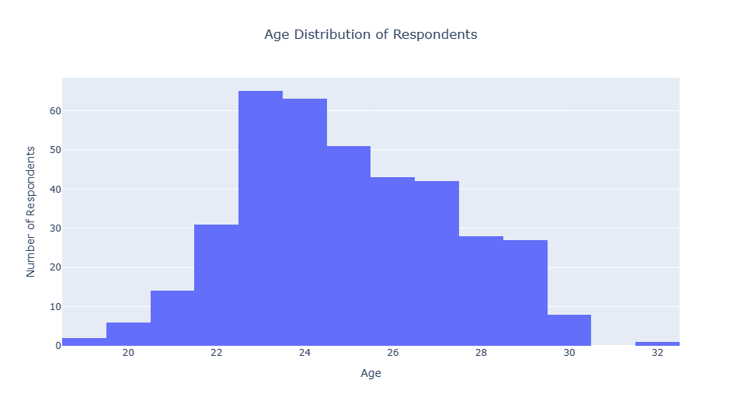

Figure 2: Age Distribution of Respondents

### 1.4 RELIGION OF THE RESPONDENTS

Table 6 shows the religious distribution of the respondents. It is observed that 85% of the population are Christians with a value count of 324 with Muslims making up 14.7% and a value count of 56. Interestingly just 1 person is seen to be Agnostic with a percentage of 0.3%. Figure 3 shows the graphical representation of the respondents’ ages.

Table 6: Religion of the Respondents

|  |  |  |
| --- | --- | --- |
| Religion | Frequencies | Percentage |
| Christian | 324 | 85.0 |
| Muslim | 56 | 14.7 |
| Agnostic | 1 | 0.3 |
| Total | 381 | 100.0 |

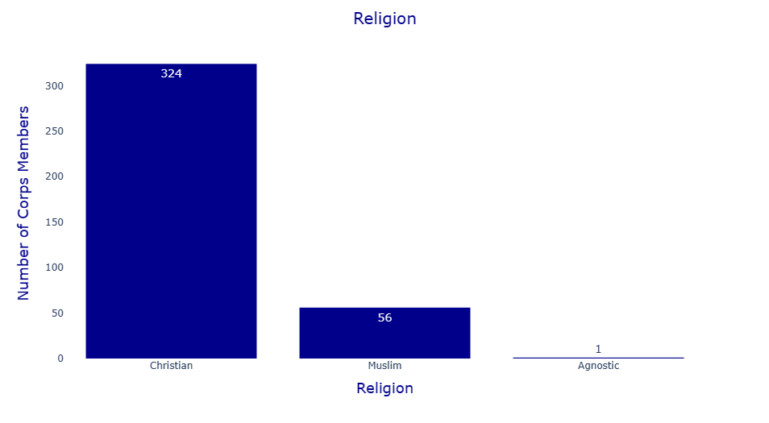

Figure 3: Religion Distribution of Respondents

### 1.5 MARITAL STATUS OF THE RESPONDENTS

This section shows the marital status of the respondents. From Table 7, 97.9% of the respondents making up 373 of the total number of respondents are single while 8 of the respondents, 2.1% of the entire population are married. The graphical representation of the marital status distribution is depicted in Figure 4.

Table 7: Marital Status of Respondents

|  |  |  |
| --- | --- | --- |
| Marital status | Frequencies | Percentage |
| Single | 373 | 97.9 |
| Married | 8 | 2.1 |
| Total | 381 | 100.0 |

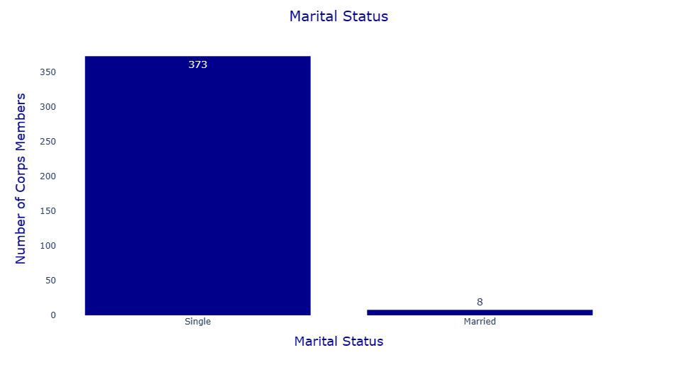

Figure 4: Marital Status of the Respondents.

### 1.6 QUALIFICATION OF THE RESPONDENTS

The academic qualification of the respondents is presented in this section. Table 8 shows the academic qualification distribution of the respondents. It was observed that Bachelor's degree holders are the highest making up 69.8% of the entire population with a value count of 266 respondents. HND holders make up 29.9% of the population with a value count and only 1 respondent has an MBBS degree with a percentage of 0.3%. Figure 5 shows the qualification distribution of the respondents.

Table 8: Qualification of the Respondents:

|  |  |  |
| --- | --- | --- |
| Qualifications | Frequencies | Percentage |
| Bachelor Degree | 266 | 69.8 |
| Higher National Diploma (HND) | 114 | 29.9 |
| MBBS | 1 | 0.3 |
| Total | 381 | 100.0 |

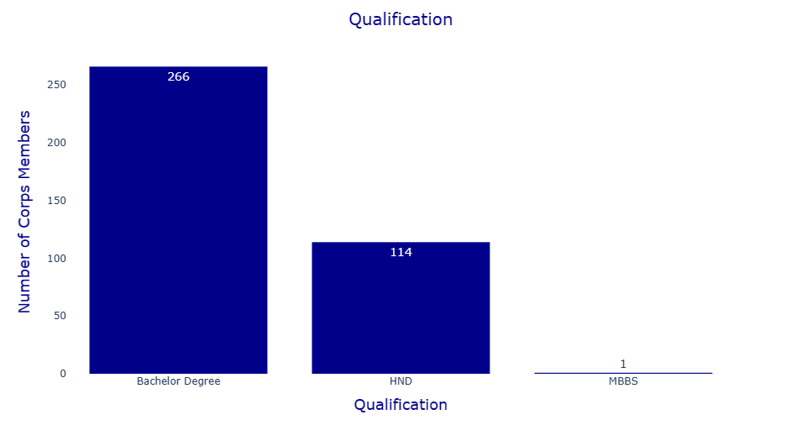

Figure 5: Qualification of Respondents

# 2.0. MOBILIZATION FOR NATIONAL SERVICE SECTION

The responses from the respondents (Corps Members) on their mobilization to the NYSC scheme are assessed in this section.

### 2.1 CONCESSIONAL DEPLOYMENT

The responses of Corps members on whether they were on concessional deployment are shown in Table 9. Analysis shows that 205 respondents, which is 53.8% of the population, are not on concessional deployment while the remaining 176 making up 46.2% are on concessional deployment. Figure 6 gives a graphical information of the data.

Table 9: CONCESSIONAL DEPLOYMENT

|  |  |  |
| --- | --- | --- |
| ARE YOU ON CONCESSIONAL DEPLOYMENT? | Frequencies | Percentage % |
| Yes | 176 | 46.2 |
| No | 205 | 53.8 |
| Total | 381 | 100.0 |

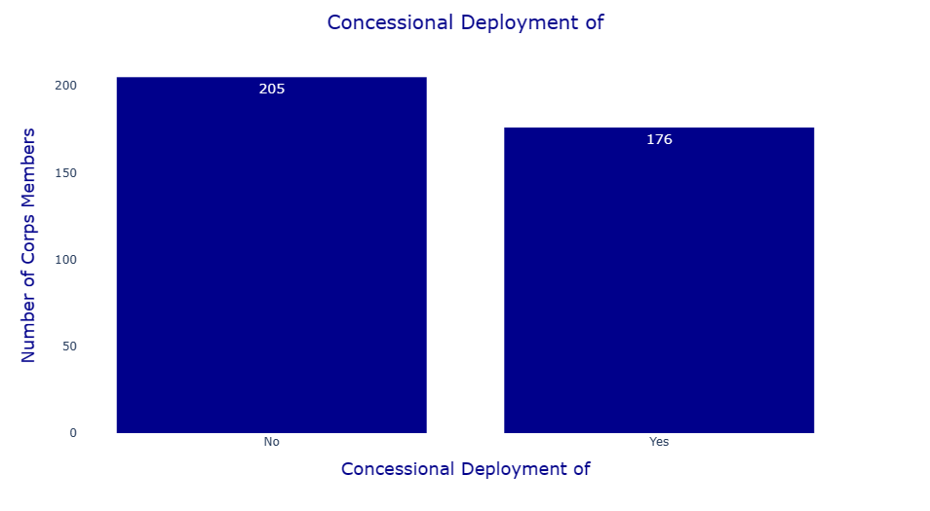

Figure 6: Concessional Deployment

### 2.2 CORPS MEMBERS’ FEELINGS ABOUT MOBILIZATION FOR NATIONAL SERVICE

The feeling of the respondents concerning their mobilization for NYSC is assessed in this section. From Table 10, it is seen that 259 respondents making up 68% of the population were eager for mobilization, 99 respondents (26%) felt indifferent, and 23 respondents (6%) felt reluctant for their mobilization for NYSC. A graphical representation of the information is shown in Figure 7.

Table 10: Response to Feelings about Mobilization for NYSC

|  |  |  |
| --- | --- | --- |
| HOW DO YOU FEEL ABOUT YOUR MOBILIZATION FOR NATIONAL SERVICE? | Frequencies | Percentage |
| Eager | 259 | 68.0 |
| Indifferent | 99 | 26.0 |
| Reluctant | 23 | 6.0 |
| Total | 381 | 100.0 |

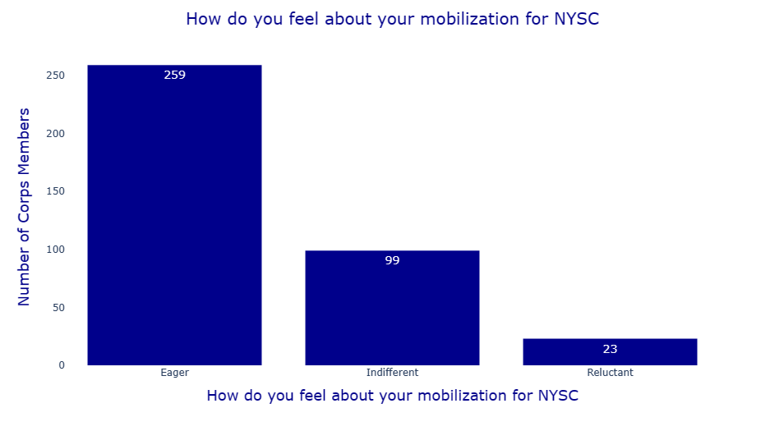

Figure 7: Feelings about Mobilization for National Service

### 2.3: RESPONDENT RATING ON THE PURPOSE FOR ESTABLISHING THE NYSC SCHEME

The ratings of respondents concerning the purpose of the establishment of the NYSC scheme is assessed in this section. From Table 11, 208 respondents making up 54.6 per cent of the entire population rate the purpose of the scheme as Very High, 21 respondents (5.5 per cent) rated it to be High, 138 respondents (36.2 per cent) rates it to be Low, while 14 respondents making up 3.7 percent of the entire population rate it to be Very Low. Chart 2 gives a graphical information of the ratings.

Table 11: Ratings for the Purpose of the NYSC Scheme

|  |  |  |
| --- | --- | --- |
| HOW DO YOU RATE THE PURPOSE FOR ESTABLISHING THE NYSC SCHEME? | Frequencies | Percentage |
| Very High | 208 | 54.6 |
| High | 21 | 5.5 |
| Low | 138 | 36.2 |
| Very Low | 14 | 3.7 |
| Total | 381 | 100.0 |

Chart 2: Rating the NYSC Scheme by the Corps members

# 3.0. REGISTRATION SECTION

The responses of the respondents concerning the registration and call up process will be assess in this section. The method of call up letter, the registration on camp, Kits collection and reception on arrival to camp is evaluated.

### 3.1 COLLECTION OF CALL-UP-LETTER METHODS

The responses on the mode of collection of Call-Up letter is evaluated below. From Table 12, 379 of the respondents accounting for 99.5 percent of the entire population collected their call up letter online while just 2 respondents which is 0.5 percent of the entire population collected their call up letter from their school. Figure 8 shows the plot of the responses.

Table 12: Method of Collection of Call up Letter

|  |  |  |
| --- | --- | --- |
| YOU MUST HAVE REGISTERED ONLINE FOR THE NYSC. DID YOU COLLECT YOUR CALL-UP LETTER FROM SCHOOL OR YOU PRINTED ONLINE? | Frequencies | Percentage |
| Collected From School | 2 | 0.5 |
| Printed Online | 379 | 99.5 |
| Total | 381 | 100.0 |

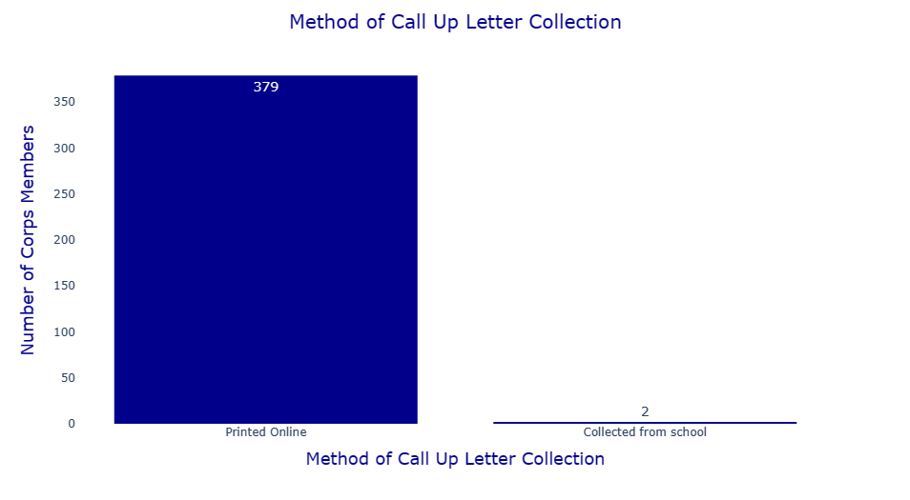

Figure 8: Method of collection of call-up letter

### 3.2 WHICH OF THESE TWO PROCESSES DO YOU THINK IS BETTER?

The best method for collection of the call-up letter is presented in this section. From Table 13, 374 respondents making up 98.2 percent of the population preferred online calls while 7 respondents making up 1.8 percent preferred to get theirs from School.

13: Preferred method of collection of call-up letter

|  |  |  |
| --- | --- | --- |
| PREFERABLE METHOD OF COLLECTING CALL-UP LETTER | Frequencies | Percentage |
| Online Call-Up | 374 | 98.2 |
| Call-Up From School | 7 | 1.8 |
| Total | 381 | 100.0 |

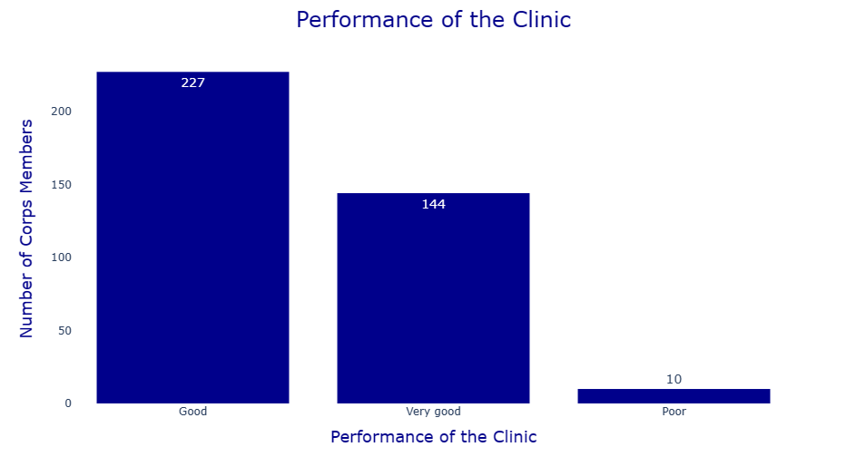

Figure 9: Preferred method of collecting call-up letter

### 3.3 REGISTRATION IN CAMP

The experience of registration in camp by respondents is assessed in this section. From Table 14 230 respondents (60.4 per cent) indicated that camp registration was stressful, while 151 respondents ( 39.6 per cent) indicated that the camp registration was not stressful.

Table 14: Experience of registration in camp

|  |  |  |
| --- | --- | --- |
| HOW WAS THE REGISTRATION ON CAMP? | Frequencies | Percentage (%) |
| Not Stressful | 151 | 39.6 |
| Stressful | 230 | 60.4 |
| Total | 381 | 100.0 |

Chart 3: Experience of registration in camp

### 3.4 KIT COLLECTION

The responses on the time taken to collect kits from respondents are assessed in this section. It is observed from Table 15 that, 169 respondents made up of 44.4 per cent of the entire respondents took less than 30 minutes to get their kits. 141 respondents constituting 37 percent of the entire respondents took an hour to get their respondents, while 71 respondents constituting 18.6 percent of the entire population indicated it took them less than one hour but more than thirty minutes to get their kits. Graphical overview of this information is shown in Figure 10.

Table 15: Time taken to collect kits

|  |  |  |
| --- | --- | --- |
| HOW LONG DID IT TAKE YOU TO COLLECT YOUR KIT? | Frequencies | Percentage (%) |
| 30 Minutes | 169 | 44.4 |
| 1 Hour | 141 | 37.0 |
| More Than 30 Minutes But Not Up To 1 Hour | 71 | 18.6 |
| Total | 381 | 100.0 |

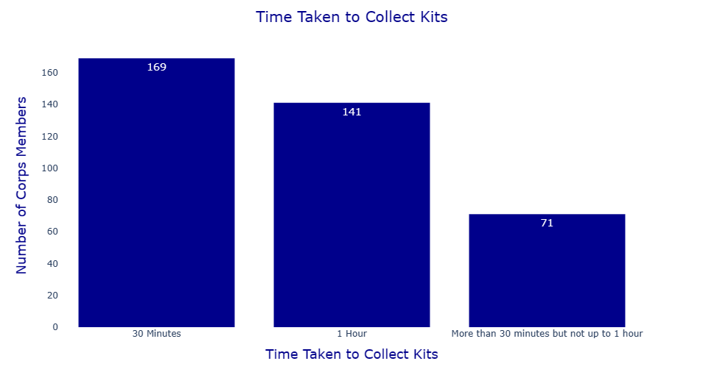

Figure 10: Time taken to collect kits

### 3.5 SATISFACTION ON KIT ISSUED.

The satisfaction of respondents on the kits issued to them is assess in this section. From Table 16 it was noted that, 216 of the respondents constituting 56.7 percent of the entire population are satisfied with the kits issued to them while 165 respondents constituting 43.3 percent were not satisfied with the kits issued to them. A plot of the responses is shown in Figure 11.

|  |  |  |
| --- | --- | --- |
| WERE YOU SATISFIED WITH THE KITS ITEMS ISSUED TO YOU? | Frequencies | Percentage (%) |
| Yes | 216 | 56.7 |
| No | 165 | 43.3 |
| Total | **381** | **100.0** |

Figure 11: Satisfaction on kits issued

### 3.6 RECEPTION GIVEN ON ARRIVAL TO CAMP

The responses of the respondents on the quality of reception received on arrival is presented in this section. From Table 16, 361 of the respondents making up of 94.8 percent of the entire population indicated they received friendly reception on their arrival. Whereas 20 respondents constituting of 5.2 percent indicated the reception they received was not friendly.

Table 16: Quality of reception received on arrival at the camp

|  |  |  |
| --- | --- | --- |
| HOW CAN YOU DESCRIBE THE RECEPTION YOU WERE GIVEN ON ARRIVAL AT THE CAMP? | Frequencies | Percentage |
| Friendly | 361 | 94.8 |
| Not Friendly | 20 | 5.2 |
| Total | 381 | 100.0 |

Chart 4 Reception received on arrival to the camp.

### GIVEN RIGHT KIT SIZE

The assessment on the size of kit issued to respondents is presented in this section. From Table 17, it is seen that 258 of the respondents accounting for 67.7 percent of the entire population said they were given the right size of kit while 123 respondents making up 32.3 indicated they were not given the right size.

Table 17: Size of kit issued

|  |  |  |
| --- | --- | --- |
| WERE YOU ISSUED YOUR RIGHT SIZES? | Frequencies | Percentage (%) |
| Yes | 258 | 67.7 |
| No | 123 | 32.3 |
| Total | 381 | 100.0 |

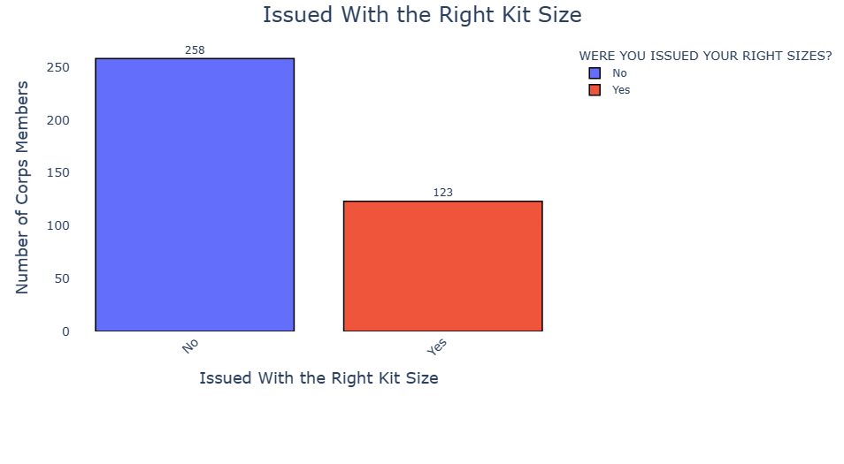

Figure 12: Size of kit issued

# 4.0 FEEDING SECTION

In this section the responses of respondents on the quality of food served is presented.

**SATISFACTORY LEVEL ON FEEDING**

The satisfaction of the correspondents on various feeding metrics is presented in Table 18.

|  |  |  |  |  |  |  |  |  |
| --- | --- | --- | --- | --- | --- | --- | --- | --- |
| Very Satisfied | % very Satisfied | Satisfied | % Satisfied | Fairly  Satisfied | %fairly  Satisfied | Not Satisfied | % not Satisfied | Total |
| 25 | 6.6 | 128 | 33.6 | 163 | 42.8 | 65 | 17.1 | 381 |
| 26 | 6.8 | 118 | 31.0 | 167 | 43.8 | 70 | 18.4 | 381 |
| 86 | 22.6 | 220 | 57.7 | 64 | 16.8 | 11 | 2.9 | 381 |
| 90 | 23.6 | 187 | 49.1 | 75 | 19.7 | 29 | 7.6 | 381 |
|  |  |  |  |  |  |  |  |  |

A summary of the table highlights the following:

**Quantity of Food:** 33.6% were satisfied, 6.6% were very satisfied, 42.8% were fairly satisfied, and 17.1% were not satisfied with the quantity of the food served.

**Quality of Food:** With regard to the quality of food, 6.8% were very satisfied, 31.0% were satisfied, 43.8% were fairly satisfied and 18.4% were not satisfied.

**Involvement of Food**: For involvement of Corps members in preparation of food, 22.6% were very satisfied, 49.1% were satisfied, while 19.7% were fairly satisfied and 7.6% were not satisfied.

**Method Serving Mode:** For mode of serving, 23.6% were very satisfied, 49.1% were satisfied, 19.7% were fairly satisfied and 7.6% were not satisfied.

A graphical representation of the above information is illustrated in Chart 5.

Chart 5: Satisfactory Level on Feeding

# 5.0. HEALTH CARE SECTION

The responses of respondents of the health parameters such as availability of camp clinic and performance of camp clinic is assess in this section.

### 5. 1 FUCTIONING OF THE CAMP CLINIC

The response of the respondents on camp clinic is assess in this section. Table 18 showed that, 375 of the respondents constituting 98.4 percent of the entire population indicated availability of a functional camp clinic. Also, 6 of the respondents amounting to 1.6 percent responded that there is no functional camp clinic. Fig 13 depicts functional camp clinic.

Table 18: Availability of a functional camp clinic.

|  |  |  |
| --- | --- | --- |
| WAS THERE A FUNCTIONAL CAMP CLINIC? | Frequency | Percentage |
| Yes | 375 | 98.4 |
| No | 6 | 1.6 |
| Total | 381 | 100.0 |

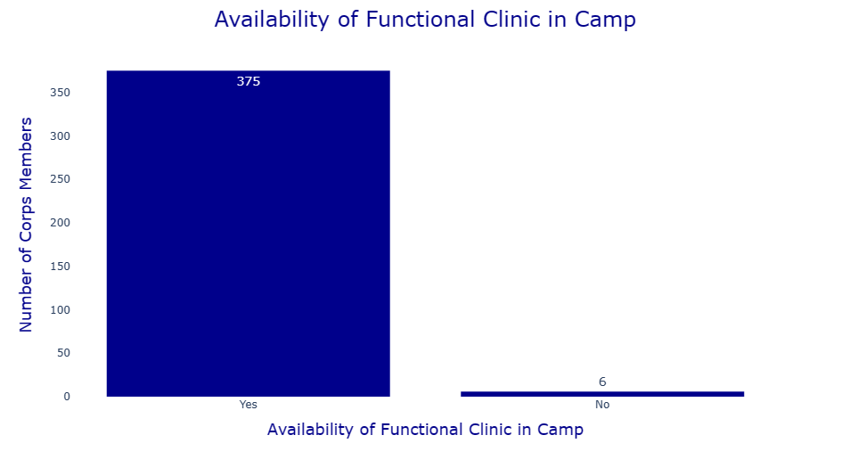

Figure 13: Availability of functional camp clinic

**TABLE 5.2: PERFOMANCE OF THE CLINIC**

The ratings on the performance of the clinic is presented in Table 19. A total of 227 respondents constituting of 59.6 percent, rated the performance of the clinic to be very good. Furthermore, 144 respondents constituting 37.8 percent of the respondents rated the performance of the camp clinic to be good. Furthermore, 10 respondents amounting to 2.6 percent of the respondents rated the performance of clinic to be poor.

Table 19: Rating on the performance of camp clinic

|  |  |  |
| --- | --- | --- |
| HOW DO YOU RATE THE PERFORMANCE OF THE CLINIC? | Frequency | Percentage |
| Very Good | 227 | 59.6 |
| Good | 144 | 37.8 |
| Poor | 10 | 2.6 |
| Total | 381 | 100.0 |



Figure 14: Performance of the clinic.

# 6.0. CAMP ADMINISTRATION SECTION

The responses of the respondents on the administration of the camp is presented in this section.

### 6.1 CORPS MEMBERS CO-OPTED INTO CAMP COMMITEES

The level of co-option of corps members into camp committees is assessed in this section. From Table 20, it is observed that, 359 of the respondents, constituting of 94.2 percent of the entire population agreed that Corps members were cop-opted into camp committees while 22 of the respondents amounting to 5.8 percent of the entire population disagreed on the integration of Corp Members into camp committees. Figure 15 shows a plot of the responses.

Table 20: Corps Member integration into camp committees

|  |  |  |
| --- | --- | --- |
| WERE CORPS MEMBERS CO-OPTED INTO CAMP COMMITTEES? | Response | Frequencies |
| Yes | 359 | 94.2 |
| No | 22 | 5.8 |
| Total | 100.0 | 444 |

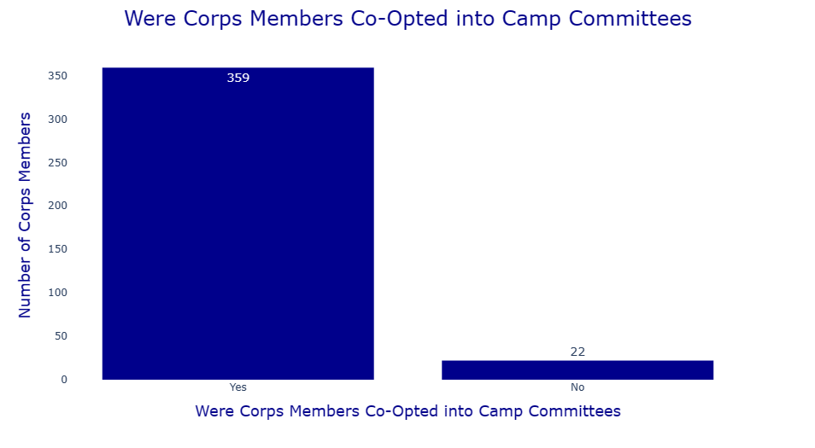

Figure 15: Co-option of Corps members into camp committees.

**6.2 EFFECTIVENESS OF CAMP COMMITTEE**

The assessment on the effectiveness of camp committees is discussed in this section below. Table 21 presents the ratings of the camp committee by the respondents.

Table 21: Ratings on the effectiveness of camp committees

|  |  |  |  |  |  |  |  |  |  |
| --- | --- | --- | --- | --- | --- | --- | --- | --- | --- |
| HOW EFFECTIVE WERE THE FOLLOWING CAMP COMMITTEES | Very Effective | Very Effective(%) | Effective | Effective (%) | Ineffective | Ineffective(%) | Don’t  Know | Don’t  Know  (%) | Total |
| Registration | 169 | 44.4 | 184 | 48.3 | 25 | 6.6 | 3 | 0.8 | 381 |
| Food | 117 | 30.7 | 211 | 55.4 | 39 | 10.2 | 14 | 3.6 | 381 |
| Health | 189 | 30.7 | 177 | 55.4 | 10 | 10.23 | 5 | 3.7 | 381 |
| Socials | 178 | 46.7 | 181 | 47.5 | 17 | 4.5 | 5 | 1.3 | 381 |
| Disciplinary | 249 | 65.4 | 124 | 32.5 | 6 | 1.6 | 2 | 0.5 | 381 |
| Maintenance | 157 | 41.2 | 197 | 51.7 | 14 | 3.7 | 13 | 3.4 | 381 |
| Lectures | 209 | 54.9 | 146 | 38.3 | 20 | 5.2 | 6 | 1.6 | 381 |
| Security | 270 | 70.9 | 101 | 26.5 | 8 | 2.1 | 2 | 0.5 | 381 |
| Camp Market | 168 | 44.1 | 188 | 49.3 | 17 | 4.5 | 8 | 2.1 | 381 |
| Stores | 129 | 33.9 | 208 | 54.6 | 26 | 6.8 | 18 | 4.7 | 381 |
| OBS | 225 | 59.1 | 147 | 38.6 | 9 | 2.4 | 0 | 0.0 | 381 |
| Sport | 175 | 45.9 | 194 | 50.9 | 10 | 2.6 | 2 | 0.5 | 381 |

Figure 16 shows a graphical representation of the effectiveness of the various camp committees.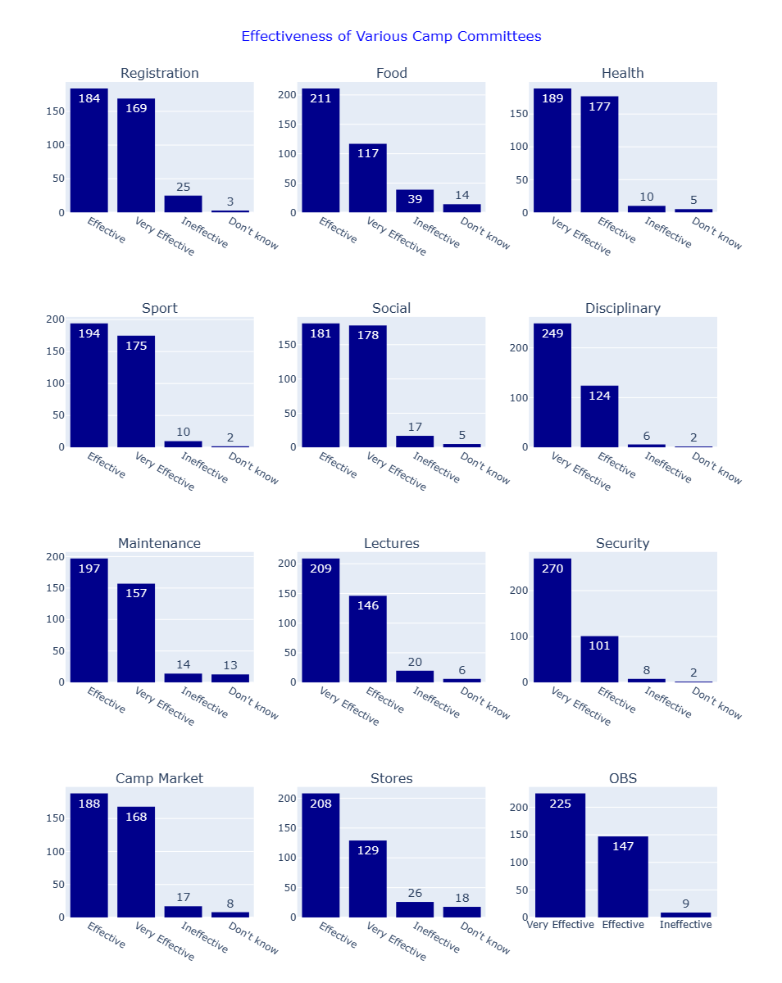

Figure 16: Effectiveness of Camp Committees

A summary of findings from the results obtained are:

* **Registration Committee**: Highly effective, with 44.4% rating it "very effective" and 48.3% rating it "effective." Only 6.6% found it "ineffective," and 0.8% had no opinion.
* **Food Committee**: Effective for most, with 30.7% "very effective" and 55.4% "effective." A smaller portion, 10.2%, found it "ineffective," while 3.6% were unsure.
* **Health Committee**: Rated highly, with 30.7% "very effective" and 55.4% "effective." Only 10.23% deemed it "ineffective," and 3.7% had no opinion.
* **Socials Committee**: Mostly positive feedback, with 46.7% "very effective" and 47.5% "effective." Only 4.5% found it "ineffective," and 1.3% were unsure.
* **Disciplinary Committee**: Very well-received, with 65.4% "very effective" and 32.5% "effective." Only 1.6% found it "ineffective," and 0.5% had no opinion.
* **Maintenance Committee**: Effective for most, with 41.2% "very effective" and 51.7% "effective." Only 3.7% found it "ineffective," and 3.4% were unsure.
* **Lectures Committee**: Positively rated, with 54.9% "very effective" and 38.3% "effective." A small portion, 5.2%, found it "ineffective," while 1.6% were unsure.
* **Security Committee**: Highly effective, with 70.9% "very effective" and 26.5% "effective." Only 2.1% found it "ineffective," and 0.5% had no opinion.
* **Camp Market Committee**: Generally positive feedback, with 44.1% "very effective" and 49.3% "effective." A small portion, 4.5%, found it "ineffective," and 2.1% were unsure.
* **Stores Committee**: Mostly effective, with 33.9% "very effective" and 54.6% "effective." Some, 6.8%, found it "ineffective," and 4.7% had no opinion.
* **OBS (Orientation Broadcasting Service) Committee**: Well-rated, with 59.1% "very effective" and 38.6% "effective." Only 2.4% found it "ineffective."
* **Sports Committee**: Effective for most, with 45.9% "very effective" and 50.9% "effective." Only 2.6% found it "ineffective," and 0.5% were unsure.

Overall, the majority of the committees received positive feedback, with high percentages of participants rating them as "very effective" or "effective."

### 6.3 THE LEVEL OF CORPS MEMBERS’ PARTICIPATION IN CAMP ACTIVITIES

This section evaluates the level of corps members' participation in various camp activities. Table 22 shows the level of Corps’ members activities in camp while Chart 6 gives a graphical representation of the information.

|  |  |  |  |  |  |  |  |  |  |
| --- | --- | --- | --- | --- | --- | --- | --- | --- | --- |
| ASSESS THE LEVEL OF CORPS MEMBERS’ PARTICIPATION IN CAMP ACTIVITIES | Very Effective | Very Effective (%) | Effective | Effective (%) | Ineffective | Ineffective (%) | Don't know | Don't  Know (%) | Total |
| Food | 152 | 39.9 | 203 | 53.3 | 24 | 6.3 | 2 | 0.5 | 381 |
| Health | 193 | 50.7 | 173 | 45.4 | 7 | 1.8 | 8 | 2.1 | 381 |
| Social | 207 | 54.3 | 159 | 41.7 | 12 | 3.2 | 3 | 0.8 | 381 |
| Disciplinary | 195 | 51.2 | 168 | 44.1 | 13 | 3.4 | 5 | 1.3 | 381 |
| Maintenance | 184 | 48.3 | 175 | 45.9 | 16 | 4.2 | 6 | 1.6 | 381 |
| Lectures | 188 | 49.3 | 169 | 44.4 | 22 | 5.8 | 2 | 0.5 | 381 |
| Security | 210 | 55.1 | 144 | 37.8 | 21 | 5.5 | 6 | 1.6 | 381 |
| OBS | 227 | 59.6 | 145 | 38.1 | 7 | 1.8 | 2 | 0.5 | 381 |
| Sports | 205 | 53.8 | 165 | 43.3 | 9 | 2.4 | 2 | 0.5 | 381 |
| Camp Market | 180 | 47.2 | 174 | 45.7 | 19 | 5.0 | 8 | 2.1 | 381 |
| Stores | 163 | 42.8 | 189 | 49.6 | 14 | 3.7 | 15 | 3.9 | 381 |
| SAED | 211 | 55.4 | 149 | 39.1 | 16 | 4.2 | 5 | 1.3 | 381 |

Table 22 Level of corps' Members participation in Camp Activities.

Chart 6: The level Corps’ members participation in camp committees.

From Table 22 and Chart 6, the following information are deduced:

1. **Food**: The majority participated effectively, with 39.9% rating their participation as "very effective" and 53.3% as "effective." Only 6.3% found it "ineffective," and 0.5% were unsure.
2. **Health**: High participation levels, with 50.7% "very effective" and 45.4% "effective." A small portion, 1.8%, found it "ineffective," and 2.1% were unsure.
3. **Social**: Most corps members participated well, with 54.3% "very effective" and 41.7% "effective." Only 3.2% found it "ineffective," and 0.8% were unsure.
4. **Disciplinary**: Strong participation, with 51.2% "very effective" and 44.1% "effective." Only 3.4% found it "ineffective," and 1.3% were unsure.
5. **Maintenance**: Effective participation, with 48.3% "very effective" and 45.9% "effective." A small portion, 4.2%, found it "ineffective," and 1.6% were unsure.
6. **Lectures**: High participation, with 49.3% "very effective" and 44.4% "effective." Only 5.8% found it "ineffective," and 0.5% were unsure.
7. **Security**: Well-participated, with 55.1% "very effective" and 37.8% "effective." Only 5.5% found it "ineffective," and 1.6% were unsure.
8. **OBS (Orientation Broadcasting Service)**: Very high participation, with 59.6% "very effective" and 38.1% "effective." Only 1.8% found it "ineffective," and 0.5% were unsure.
9. **Sports**: High participation, with 53.8% "very effective" and 43.3% "effective." Only 2.4% found it "ineffective," and 0.5% were unsure.
10. **Camp Market**: Effective participation, with 47.2% "very effective" and 45.7% "effective." Only 5.0% found it "ineffective," and 2.1% were unsure.
11. **Stores**: Good participation, with 42.8% "very effective" and 49.6% "effective." Only 3.7% found it "ineffective," and 3.9% were unsure.
12. **SAED (Skills Acquisition and Entrepreneurship Development)**: Strong participation, with 55.4% "very effective" and 39.1% "effective." Only 4.2% found it "ineffective," and 1.3% were unsure.

Overall, the majority of corps members actively participated in camp activities, with high percentages rating their participation as either "very effective" or "effective." The percentages of those finding participation "ineffective" or being unsure were consistently low across all activities.

**6.4 Organization of Camp and Structures Activities.**

This section assesses the organization of various aspects of the camp. Results of the respondents responses are presented in Table 23. A graphical view of the results are presented in Chart 7.

Table 23: Camp Organization / Structure

|  |  |  |  |  |  |  |  |  |  |
| --- | --- | --- | --- | --- | --- | --- | --- | --- | --- |
| HOW ORGANIZED WERE THE FOLLOWING? PLEASE RATE ACCORDINGLY | Very organized | % Very organized | organized | % organized | Not Organized | % Not Organized | Don’t  know | % Don’t  know | Total |
| Directional signpost | 235 | 61.7 | 139 | 36.5 | 4 | 1.0 | 3 | 0.8 | 381 |
| Registration | 201 | 52.8 | 154 | 40.4 | 23 | 6.0 | 3 | 0.8 | 381 |
| Reception at the gate | 268 | 70.3 | 112 | 29.4 | 1 | 0.3 | 0 | 0 | 381 |
| Accommodation | 195 | 51.2 | 156 | 40.9 | 28 | 7.4 | 2 | 0.5 | 381 |
| Feeding | 149 | 39.2 | 204 | 53.5 | 18 | 4.7 | 10 | 2.6 | 381 |
| Kitting | 174 | 45.7 | 177 | 46.5 | 27 | 7 | 3 | 0.8 | 381 |

Chart 7: Camp Organization/Structure

A summary of findings from Table 23 and Chart 7 on the level of Organization and structure is summarized thus:

1. **Directional Signpost**: Highly organized, with 61.7% rating it "very organized" and 36.5% as "organized." Only 1.0% found it "not organized," and 0.8% were unsure.
2. **Registration**: Generally well-organized, with 52.8% rating it "very organized" and 40.4% as "organized." A small portion, 6.0%, found it "not organized," and 0.8% were unsure.
3. **Reception at the Gate**: Excellent organization, with 70.3% rating it "very organized" and 29.4% as "organized." Only 0.3% found it "not organized," with no respondents unsure.
4. **Accommodation**: Well-organized, with 51.2% rating it "very organized" and 40.9% as "organized." A small portion, 7.4%, found it "not organized," and 0.5% were unsure.
5. **Feeding**: Organized for most, with 39.2% rating it "very organized" and 53.5% as "organized." A smaller portion, 4.7%, found it "not organized," and 2.6% were unsure.
6. **Kitting**: Mostly organised, with 45.7% rating it "very organized" and 46.5% as "organized." Only 7.0% found it "not organized," and 0.8% were unsure.

Overall, most aspects of the camp were well-organized, with high percentages of participants rating them as "very organized" or "organized." The percentages of those finding them "not organized" or being unsure were consistently low.

**6.5 EFFECTIVENESS OF GROUPS AND ACTIVITIES IN THE CAMP**

This section evaluates the effectiveness of various activities during the orientation course. Table 24 gives and overall results of respondents and their responses. Similarly, Figure 17 gives a graphical overview of the responses.

Table 24: Effectiveness of Groups and Activities.

|  |  |  |  |  |  |  |  |  |  |
| --- | --- | --- | --- | --- | --- | --- | --- | --- | --- |
| HOW EFFECTIVE WERE THE FOLLOWING? | Very  Effective | Very  Effective  (%) | Effective | Effective  (%) | Ineffective | Ineffective  (%) | Don’t know | Don’t know  % | Total |
| Medical care | 190 | 49.9 | 169 | 44.4 | 13 | 3.4 | 9 | 2.4 | 381 |
| Physical training | 246 | 64.6 | 124 | 32.5 | 7 | 1.8 | 4 | 1.0 | 381 |
| Drill and parade | 257 | 67.5 | 122 | 29.4 | 7 | 1.8 | 5 | 1.3 | 381 |
| Man O’ War | 247 | 64.8 | 125 | 32.8 | 6 | 0.78 | 3 | 1.6 | 381 |
| Lectures | 232 | 60.9 | 133 | 34.9 | 12 | 3.1 | 4 | 1.0 | 381 |
| Professional Lectures | 221 | 58.0 | 143 | 37.5 | 11 | 2.9 | 6 | 1.6 | 381 |
| SAED activities | 234 | 61.4 | 128 | 33.6 | 12 | 3.1 | 7 | 1.8 | 381 |
| Games and sports | 218 | 57.2 | 150 | 39.4 | 11 | 2.9 | 2 | 0.5 | 381 |
| Orientation course in general | 234 | 62.2 | 136 | 35.7 | 6 | 1.6 | 2 | 0.5 | 381 |

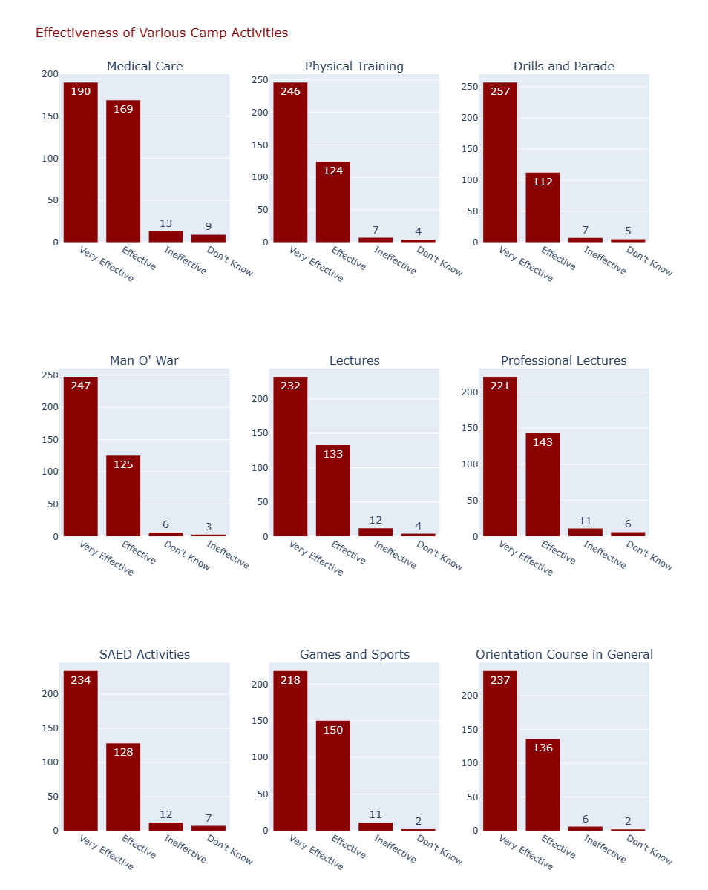

Figure 17: Effectiveness of Groups and Activities.

From Table 24 and Figure 17, the summary of their responses are seen in the table below.

1. **Medical Care**: Generally effective, with 49.9% rating it "very effective" and 44.4% as "effective." Only 3.4% found it "ineffective," and 2.4% were unsure.
2. **Physical Training**: Highly effective, with 64.6% rating it "very effective" and 32.5% as "effective." Only 1.8% found it "ineffective," and 1.0% were unsure.
3. **Drill and Parade**: Very effective, with 67.5% rating it "very effective" and 29.4% as "effective." Only 1.8% found it "ineffective," and 1.3% were unsure.
4. **Man O’ War**: Highly effective, with 64.8% rating it "very effective" and 32.8% as "effective." Only 0.78% found it "ineffective," and 1.6% were unsure.
5. **Lectures**: Effective for most, with 60.9% rating it "very effective" and 34.9% as "effective." Only 3.1% found it "ineffective," and 1.0% were unsure.
6. **Professional Lectures**: Generally effective, with 58.0% rating it "very effective" and 37.5% as "effective." Only 2.9% found it "ineffective," and 1.6% were unsure.
7. **SAED Activities**: Highly effective, with 61.4% rating it "very effective" and 33.6% as "effective." Only 3.1% found it "ineffective," and 1.8% were unsure.
8. **Games and Sports**: Effective for most, with 57.2% rating it "very effective" and 39.4% as "effective." Only 2.9% found it "ineffective," and 0.5% were unsure.
9. **Orientation Course in General**: Highly effective, with 62.2% rating it "very effective" and 35.7% as "effective." Only 1.6% found it "ineffective," and 0.5% were unsure.

Overall, the activities were perceived as effective, with high percentages of participants rating them as either "very effective" or "effective." The percentages of those finding the activities "ineffective" or being unsure were consistently low.

### 6.6 CAMP DISCIPLINE IN GENERAL

This section assesses the discipline of various groups involved in the camp. Table 25 and Chart 8 shows the results of the responses from respondents.

Table 25: Assessment of camp discipline.

|  |  |  |  |  |  |  |  |
| --- | --- | --- | --- | --- | --- | --- | --- |
| ASSESS CAMP DISCIPLINE | Very Disciplined | %Very Disciplined | Disciplined | % Disciplined | Not Disciplined | &Not Disciplined | Total |
| NYSC Officials | 269 | 70.6 | 111 | 29.1 | 1 | 0.3 | 381 |
| Soldiers | 316 | 82.9 | 64 | 16.8 | 1 | 0.3 | 381 |
| Police/NSCDC | 252 | 66.1 | 126 | 33.1 | 3 | 0.8 | 381 |
| Man O' War | 276 | 72.4 | 103 | 27.1 | 2 | 0.5 | 381 |
| Others (Specify) | 207 | 54.3 | 168 | 44.1 | 6 | 1.6 | 381 |

Chart 8: Assessment of camp discipline.

From Table 25 and Chart 8, the following findings are deducted:

1. **NYSC Officials**: Highly disciplined, with 70.6% rating them as "very disciplined" and 29.1% as "disciplined." Only 0.3% found them "not disciplined."
2. **Soldiers**: Extremely disciplined, with 82.9% rating them as "very disciplined" and 16.8% as "disciplined." Only 0.3% found them "not disciplined."
3. **Police/NSCDC**: Generally disciplined, with 66.1% rating them as "very disciplined" and 33.1% as "disciplined." Only 0.8% found them "not disciplined."
4. **Man O' War**: Highly disciplined, with 72.4% rating them as "very disciplined" and 27.1% as "disciplined." Only 0.5% found them "not disciplined."
5. **Others (Specify)**: Mostly disciplined, with 54.3% rating them as "very disciplined" and 44.1% as "disciplined." A small portion, 1.6%, found them "not disciplined."

Overall, the groups involved in the camp were perceived as highly disciplined, with the majority of participants rating them as either "very disciplined" or "disciplined." The percentage of those finding any group "not disciplined" was consistently low.

### 6.7 AMENABILITY OF CORPS MEMBERS TO NATIONAL SERVICE THROUGH ORIENTATION COURSE

This section discusses the amenability of Corps members to NYSC through the NYSC orientation course. From Table 26, 188 respondents indicated the orientation course has made them amenable to National Service constituting 49.3 percent of the entire population. 179 of the respondents (47 percent) finds the orientation course to be very amenable, only 14 which is just 3.7 percent of the entire population find it not amenable. Figure 18 shows a graphical representation of the findings.

Table 26: Extent to which the orientation course has made Corps members amenable to National Service.

|  |  |  |
| --- | --- | --- |
| WHAT EXTENT HAS THE ORIENTATION COURSE MADE YOU AMENABLE TO NATIONAL SERVICE? | Frequency | Percentage |
| Amenable | 188 | 49.3 |
| Very Amenable | 179 | 47.0 |
| Not Amenable | 14 | 3.7 |
| Total | 381 | 100.0 |

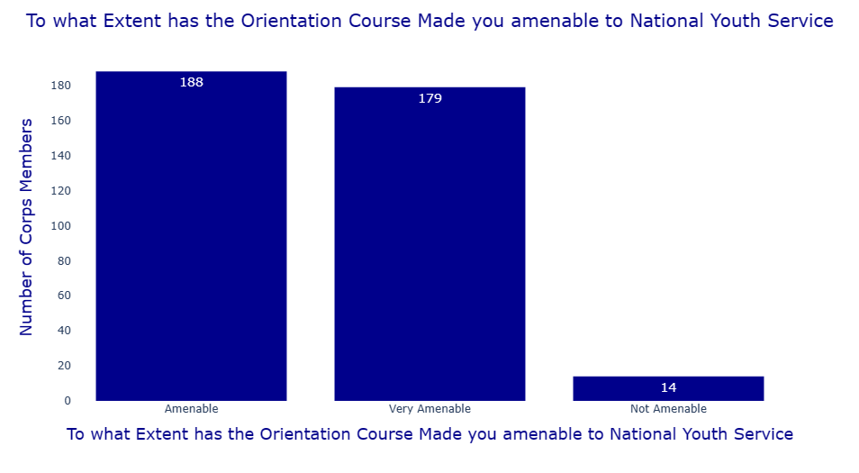

Figure 18 Extent to which the orientation course has made Corps members amenable to National Service.

### 6.8 MOST BORING ASPECT OF THE ORIENTATION COURSE

This section discusses the aspects of the orientation courses the respondents find boring. Table 27 and Figure 19 shows the representation of the respondents responses.

Table 27 Aspects of orientation courses found to be boring.

|  |  |  |
| --- | --- | --- |
| WHICH ASPECT OF THE ORIENTATION COURSE DID YOU FIND BORING? | Frequencies | Percentage |
| Other Lectures | 178 | 46.7 |
| SAED Activities | 133 | 34.9 |
| Parades & Paramilitary Training | 20 | 5.2 |
| Social Activities | 15 | 3.9 |
| Games and sports | 10 | 2.6 |
| Morning Meditation | 9 | 2.3 |
| Man O'war Activities | 7 | 1.8 |
| Nothing | 1 | 0.3 |
| SAED LECTURES | 1 | 0.3 |
| Non | 1 | 0.2 |
| Total | 381 | 100 |

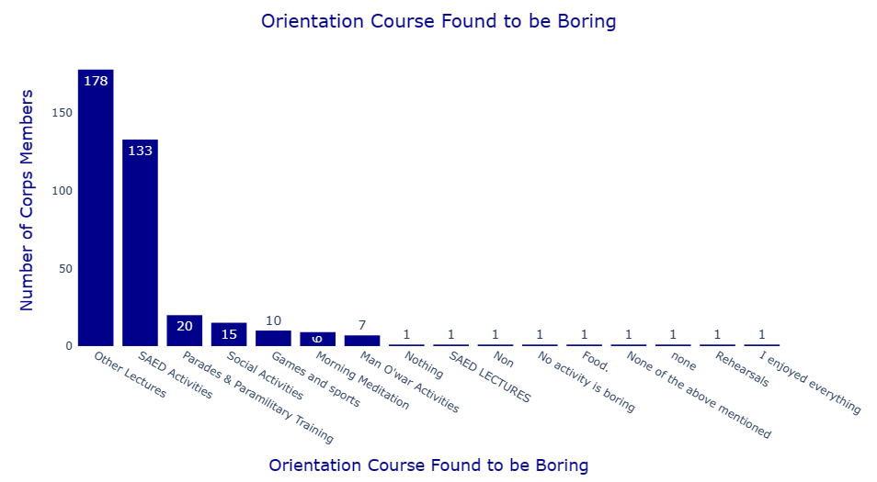

Figure 19: Aspects of orientation courses found to be boring.

From Table 27 and Figure 19 the following findings were deduced:

1. **Other Lectures**: The most frequently cited as boring, with 46.7% (133 participants) finding this aspect uninteresting.
2. **SAED Activities**: The second most frequently cited as boring, with 34.9% (133 participants) finding these lectures uninteresting.
3. **Social Activities**: Only 4.1% (15 participants) found these boring.
4. **Parades & Paramilitary Training**: A small portion, 5.2% (20 participants), found these activities boring.
5. **Morning Meditation**: Found boring by 2.3% (9 participants).
6. **Games and Sports**: Found boring by 2.0% (10 participants).
7. **Man O' War Activities**: Found boring by 1.8% (7 participants).
8. **SAED Lectures (Repeated)**: Listed again by 1 participant.
9. **No Activity is Boring**: Only 1 participant indicated that no activities were boring.
10. **Nothing**: Listed by 1 participant.
11. **None**: Listed again by 1 participant.
12. **Rehearsals**: Listed by 1 participant.
13. **Food:** Listed by 1 participant.
14. I Enjoyed Everything: Listed by 1 participant.
15. **None of the Above**: A small portion, 1.3% (6 participants), found other unspecified activities boring.

Overall, the SAED activities and other lectures were the most commonly cited as boring, while other activities such as social activities, parades, and games had much lower percentages of participants finding them boring.

**6.9 MOST INTERESTING PART OF THE ORIENTATION COURSE**

This section evaluates which aspects of the orientation course program participants found most interesting. Table 28 and Chart gives a representation of the responses obtained from the respondents.

Table 28: Aspect of orientation course found to be interesting

|  |  |  |
| --- | --- | --- |
| WHAT ASPECT OF THE ORIENTATION COURSE PROGRAMME DID YOU FIND MOST INTERESTING? | Frequencies | Percentage |
| Everything mentioned above | 1 | 0.3 |
| Games and sports | 55 | 14.4 |
| Lights out | 1 | 0.3 |
| Man O'war Activities | 48 | 12.6 |
| Morning Meditation | 25 | 6.6 |
| None | 1 | 0.3 |
| Other Lectures | 10 | 2.6 |
| Parades & Paramilitary Training | 73 | 19.2 |
| SAED Activities | 66 | 17.3 |
| Social activities | 101 | 26.5 |
| Total | 381 | 100.0 |

Chart 8: Most interesting part of the orientation course.

Summary of findings obtained from Table 28 and Chart 8 shows that:

1. **Everything Mentioned Above**: Found most interesting by 0.3% (1 participant).
2. **Games and Sports**: Found most interesting by 14.4% (55 participants).
3. **Lights Out**: Found most interesting by 0.3% (1 participant).
4. **Man O' War Activities**: Found most interesting by 12.6% (48 participants).
5. **Morning Meditation**: Found most interesting by 6.6% (25 participants).
6. **None**: Found most interesting by 0.3% (1 participant).
7. **Other Lectures**: Found most interesting by 2.6% (10 participants).
8. **Parades & Paramilitary Training**: Found most interesting by 19.2% (73 participants).
9. **SAED Activities**: Found most interesting by 17.3% (66 participants).
10. **Social Activities**: The most frequently cited as interesting, with 26.5% (101 participants) finding this aspect the most engaging.

Summarily, social activities, parades and paramilitary training, and SAED activities were the most commonly cited as interesting, with social activities being the top choice. Other aspects such as games and sports, Man O' War activities, and morning meditation also had notable interest, while a very small percentage found everything mentioned, lights out, or none of the activities most interesting.

# SUMMARY OF REPORT

From the findings of the survey carried out, the following findings are noted:

The survey involved 1270 registered corps members in the camp, with a 30% random sample of 381 respondents. Questionnaires were administered to the corps members deployed in the state, and data analysis was conducted using Excel and Python.

#### Deployment of Corps Members

The state of origin with the highest population of Corps members deployed to the Ebonyi NYSC orientation camp is Edo state, representing 14.17% of the total. Chart 1 visually depicts the number of Corps members from each state.

#### Demographic Information

The demographic breakdown shows that 85% of the Corps members are Christians, 14.7% are Muslims, and 0.3% are Agnostic. Regarding marital status, 97.9% are single, while 2.1% are married. In terms of educational qualifications, 69.8% hold bachelor's degrees, 29.9% have HNDs, and 0.3% possess an MBBS degree.

#### Mobilization for National Service

A majority of 53.8% of respondents were not on concessional deployment, whereas 46.2% were. Concerning eagerness for mobilization, 68% were eager, 26% were indifferent, and 6% were reluctant. When asked about the purpose of the NYSC scheme, 54.6% rated it very high, 5.5% rated it high, 36.2% rated it low, and 3.7% rated it very low.

#### Registration Process

The registration process revealed that 99.5% of respondents collected their call-up letters online, with 98.2% preferring this method. During camp registration, 60.4% found the process stressful. Kit collection times varied, with 44.4% taking less than 30 minutes. Satisfaction with the kits stood at 56.7%. Furthermore, 94.8% received a friendly reception, and 67.7% received correctly sized kits.

#### Feeding

Regarding the quantity of food served, 40.2% were satisfied or very satisfied. The quality of food received similar ratings, with 37.8% expressing satisfaction. Involvement in food preparation saw 71.7% satisfied or very satisfied. For the mode of serving, 72.7% were satisfied or very satisfied. The availability of a functional camp clinic was reported by 98.4% of respondents, with 97.4% rating the clinic's performance as good or very good.

#### Camp Administration

A significant 94.2% agreed that Corps members were integrated into camp committees. The effectiveness of these committees was rated highly across the board, particularly the Disciplinary Committee (97.9% effective or very effective) and the Security Committee (97.4% effective or very effective).

#### Corps Members' Participation in Camp Committees

Participation in camp committees was generally high, with the Health Committee rated 96.1% effective or very effective, the Social Committee 96%, and the Disciplinary Committee 95.3%.

#### Organization and Structure

The camp was perceived as well-organized in several areas: 98.2% rated directional signposts as organized or very organized; 93.2% rated registration similarly; reception at the gate received a 99.7% rating for being organized or very organized. Accommodation and feeding were rated 92.1% and 92.7% organized or very organized, respectively, while kitting received a 92.2% rating.

#### Effectiveness of Camp Activities

Camp activities were deemed effective, with medical care rated 94.3% effective or very effective, physical training 97.1%, and drill and parade 96.9%. The Man O’ War activity was 97.6% effective or very effective. Lectures and professional lectures were rated 95.8% and 95.5% effective or very effective, respectively. SAED activities received a 95% effectiveness rating, while games and sports were rated 96.6%. Overall, the orientation course was considered 97.9% effective or very effective.

#### Camp Discipline

Discipline among various groups was highly rated: NYSC officials were seen as disciplined or very disciplined by 99.7%, soldiers by 99.7%, Police/NSCDC by 99.2%, and Man O' War by 99.5%. Other groups were rated 98.4% disciplined or very disciplined.

In conclusion, the NYSC orientation camp in Ebonyi was well-received, with high satisfaction rates across various metrics and low dissatisfaction rates, indicating a positive experience for the majority of the Corps members.

# RECOMMENDATION

Based on the responses of the corps member during this survey, the following recommendations were made;

1. There should be breaks during SAED lectures to sustain the attention of corps members. Also, corps members complained that the lectures were too long and boring. Camp officials can find ways to make the lectures more time-effective, learner centered and interactive.
2. The kitchen administrators should improve on the quality and quantity of food.
3. The hall should be made more conducive. It should be furnished with more chairs and fans to encourage corps members to be more attentive.
4. The registration process is time-consuming and stressful. As such, an online registration system should be adopted to make the process easy for camp officials and corps members, while enabling PCMs to quickly settle in once they arrive.
5. There should be strict adherence to time. Any lapse in time management encroaches on corps members’ time for rest and personal affairs, which hinders healthy living. For instance, social nights end at 10:00 p.m. or even later, with lights out occurring barely ten minutes after. This isn’t fair on corps members.
6. More arrangements should be made to ensure corps members get the right sizes of kits.
7. More water Tanks should be provided in male hostels to reduce the stress of male corps members going to female hostels to fetch water.
8. The prices of food and other items in the camp market should be regulated to make them more affordable for corps members.
9. The military personal should treat all corps members holistically in order to foster the goal of NYSC, foster socio-cultural integration and unity. Soldiers should be careful with the comments they make concerning ethnic groups to avoid intertribal animosity.
10. Spaces should be provided for corps members to charge their phones, power banks, etc. Not all corps members can conveniently afford to charge constantly at camp market.